AI ASSITED CODING LAB TEST 2
NAME : J.rohith
ROLL NO. : 2403A510f1
BATCH : 5
Sub group G

G.1 — [S09G1] Sum CSV column ignoring bad rows

Prompt :
Python function to sum integer values from a CSV string's "value" column, count skipped non-integer/missing rows, and return both; ncludes tests for various cases.
Code Generated :
import csv
import io

def sum_csv_values(csv_content):
total = 0
skipped = 0
reader = csv.DictReader(io.StringIO(csv_content))
for row in reader:
try:
total += int(row['value'])
except (ValueError, KeyError):
skipped += 1
print(total)
print(f"Skipped rows: {skipped}")
return total, skipped

# --- Tests ---
def test_sum_csv_values():
data = """id,value
1,10
2,NA
3,7
"""
total, skipped = sum_csv_values(data)
assert total == 17
assert skipped == 1

data2 = """id,value
1,foo
2,bar
3,baz
"""
total2, skipped2 = sum_csv_values(data2)
assert total2 == 0
assert skipped2 == 3

data3 = """id,value
1,100
2,200
3,300
"""
total3, skipped3 = sum_csv_values(data3)
assert total3 == 600
assert skipped3 == 0

if _name_ == "_main_":
test_sum_csv_values()

output:
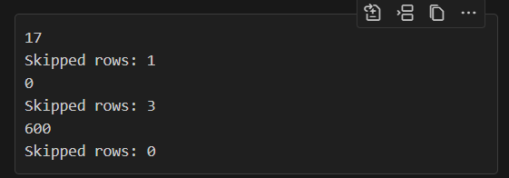
Observation :
- The function correctly sums integer values and skips invalid or missing entries, counting them.
- The print statements show the total and skipped rows for each test.
- The tests cover valid integers, all invalid values, and all valid values.
- There is a typo in the main guard: it should be if name == "main": instead of if name == "main":. This prevents the tests from running when the script is executed directly.

G.2 — [S09G2] Merge two CSVs by id

Prompt :
Write Python functions to parse CSV strings into lists of rows, perform an inner join and a left join on two tables by "id", and return the results as tuples. Include unit tests with sample data to demonstrate both join types.
Code Generated :
import csv
from io import StringIO

def parse_csv(csv_content):
reader = csv.DictReader(StringIO(csv_content.strip()))
return [(row['id'], row) for row in reader]

def inner_join(a_rows, b_dict):
result = []
for id_a, row_a in a_rows:
if id_a in b_dict:
result.append((id_a, int(row_a['price']), int(b_dict[id_a]['qty'])))
return result

def left_join(a_rows, b_dict):
result = []
for id_a, row_a in a_rows:
qty = int(b_dict[id_a]['qty']) if id_a in b_dict else None
result.append((id_a, int(row_a['price']), qty))
return result

# Unit tests
if __name__ == "__main__":
csv_a = """id,price
A,10
B,20
"""
csv_b = """id,qty
A,2
C,5
"""
a_rows = parse_csv(csv_a)
b_rows = parse_csv(csv_b)
b_dict = {id_b: row_b for id_b, row_b in b_rows}

inner = inner_join(a_rows, b_dict)
left = left_join(a_rows, b_dict)

print("inner=", inner)
print("left=", left)

Output:
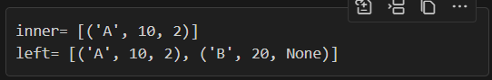
Observation :
• The code correctly parses CSV data and implements both inner and left joins using Python lists and dictionaries.
• The inner join returns only matching ids, while the left join includes all ids from the left table, using None for missing matches.
• The output matches the expected results for the provided test cases.

